Paint & Praise Schedule
August 4 – 7

Monday, Aug. 4 “Chosen”
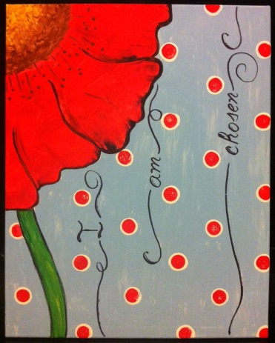
Tuesday, Aug. 5 “When I Consider”
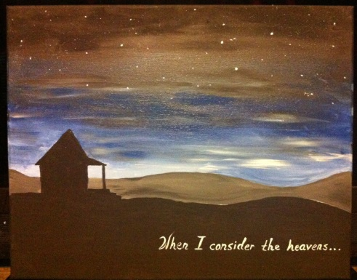
Wednesday Morning, Aug. 6
Available for Private Parties
Thursday, Aug. 7 “Rugged Cross”
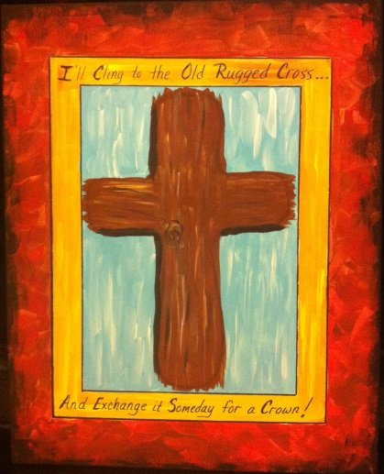
Saturday, Aug. 9
Available for Private Parties

Paint & Praise Schedule
Sept. 6 and Sept. 8 – 11

Saturday, Sept. 6
Available for Private Parties

Monday, Sept. 8 “Pray”
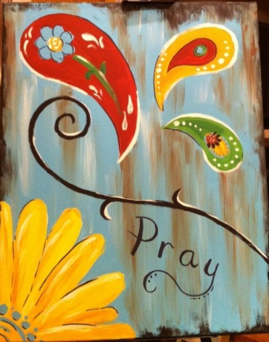
Tuesday, Sept. 9 “Hope”
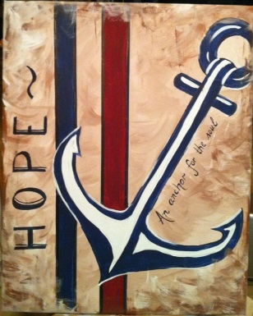
Thursday, Sept. 11 “Door”
